Smart Study Planner
Diploma in Computer Science with Artificial Intelligence
Final Project – Report
DCSAI-251-F


School of Computing and Engineering
National Institute of Business Management
Sri Lanka

NATIONAL INSTITUTE OF BUSINESS MANAGEMENT (NIBM)
Diploma in Computer Science with Artificial Intelligence

FINAL YEAR PROJECT REPORT

Project Title: Smart Study Planner
Group: 3

Submitted by:
Osanda Dilhara– KIC-DCSAI-251-F-012
Kavindu Heshan – KIC-DCSAI-251-F-023
Wethum Lansakara – KIC-DCSAI-251-F-026
Yovindu Akash – KIC-DCSAI-251-F-054

Submitted to:
National Institute of Business Management
Date: 12th January 2026

DECLARATION PAGE

I certify that this project does not incorporate without acknowledgement any material previously submitted for a Diploma in any institution and to the best of my knowledge and belief, it does not contain any material previously published or written by another person or ourselves except where due reference is made in the text. I also hereby give consent for my project report, if accepted, to be made available for photocopying and for interlibrary loans, and for the title and summary to be made available to outside organizations.

Signed: ___________________________
Date: _____________________________
PREAMBLE
Abstract
The Smart Study Planner is an AI-powered web application designed to assist students in efficiently managing their study schedules. Unlike traditional methods such as notebooks or spreadsheets, this system analyzes subjects, difficulty levels, weekly study availability, and exam dates to generate optimized, personalized study plans using Prolog reasoning. Students can enter subjects, difficulty, weekly hours, and progress, then generate AI schedules. Additionally, the system automatically sends email reminders for exams scheduled the next day, helping students stay on track. The project integrates Python (Flask), Prolog, and MySQL to provide a complete intelligent solution. Testing strategies included unit, integration, system, and user testing to ensure correctness, usability, and reliability. The Smart Study Planner reduces manual planning, balances workloads, and helps students manage stress, improving overall academic performance.

Keywords
- AI Scheduling
- Study Planner
- Prolog
- study
- scheduling
- exams
- Time Management
List of Figures
- Use Case Diagram – Smart Study Planner
- Sequence Diagram – Generate AI Schedule
- Sequence Diagram – Email Reminder
- ER Diagram – Database Structure
List of Tables
- Users Table
- Subjects Table
- Software Development Tools Table
- Testing Strategies Table
List of Acronyms and Abbreviations
- AI – Artificial Intelligence
- SDLC – Software Development Life Cycle
- MySQL – Structured Query Language Database
- Flask – Python Web Framework
- UI – User Interface

Acknowledgement

We would like to express our sincere gratitude to our lecturer and the National Institute of Business Management for providing guidance and support throughout this project. We also thank our lecturer for their valuable feedback during mid-viva, and our families for their encouragement. This project would not have been possible without the dedication and cooperation of our team members.

Chapter 1
Introduction

1.1 Introduction of the Project (What is Smart Study Planner)
The Smart Study Planner is an AI-powered web application designed to help students manage their study schedule wisely. It analyzes subjects, exam dates, difficulty levels, and weekly availability, then generates a personalized study plan using AI reasoning (Prolog). This system aims to optimize study time, balance workloads, and reduce stress for students preparing for multiple exams.

1.2 System Usage Overview
The system is structured as a web application with:
- Frontend: HTML, CSS, JavaScript for user interaction.
- Backend: Python (Flask) to process requests and communicate with the AI module.
- AI Module: Prolog logic to calculate optimal study hours.
- Database: MySQL stores users, subjects, exam schedules, and progress data.
- Email Notification: Python scripts send reminders for upcoming exams with windows task scheduler.

1.3 Current Operations
Currently, students use manual methods such as notebooks, spreadsheets, or basic digital tools to manage study schedules. These methods are time-consuming, uneven study distribution, and do not automatically adapt to new exams or changing priorities. Sometimes it can be very stressful to do plan the dates for studying.
Currently, students plan their study schedules manually or use basic digital tools.
- Notebooks & Calendars: Students write down subjects, exam dates, and study hours manually.
- Spreadsheets (Excel/Google Sheets): Some students use tables to allocate study hours, but this requires manual calculation and adjustment.
- Mobile Reminder Apps / To-Do Lists: These apps only notify students of tasks; they do not optimize schedules or adapt to changes automatically.
Limitations of Existing Solutions:
- No intelligent prioritization of subjects based on difficulty or upcoming exams.
- Uneven distribution of study hours across subjects.
- Manual updates required .
- Higher stress and lower productivity.

1.4 Users and Responsibilities / Target Users and User Roles
Target Users:
- Students preparing for school, diploma, or university examinations.
- Students who want AI-assisted study planning to manage multiple subjects effectively.
User Roles and Responsibilities:
- Registered Student:
  - Register and log in to the system.
  - Add subjects with details: name, exam date, difficulty level, weekly hours, and current progress.
  - Generate AI-based personalized study schedules using Prolog reasoning.
  - Receive email reminders for upcoming exams.
  - Update or delete subject entries as needed.

1.5 Problem Definition
Students face difficulties managing multiple subjects with varying difficulty levels and limited preparation time. Manual planning leads to inconsistent study routines, missed revisions, and stress. No system currently generates optimized, AI-based study plans tailored to each student.

1.6 Project Objectives
- Develop a web-based study planner for students to input subjects, difficulty levels, and exam dates.
- Generate personalized AI study schedules using Prolog reasoning.
- Store and manage student and schedule data in MySQL.
- Provide an intuitive and interactive web interface (Flask).
- Integrate Python, Prolog, and MySQL into a complete intelligent system.

1.7 Proposed Solution
Smart Study Planner provides an AI-assisted system that:
- Allows students to input subjects, difficulty, exam dates, weekly hours, and progress.
- Generates optimized study plans using Prolog logic.
- Stores and retrieves schedules via MySQL database.
- Sends email reminders for exams scheduled the next day.
- Presents results through a Flask-based web interface.
Key Features:
- Add subjects with relevant information
- Generate AI-based personalized study schedules
- View schedules and track progress
- Automatic email reminders for upcoming exams

Chapter 2
Methodology

2.1 Introduction
The Smart Study Planner was developed using the SDLC and Waterfall model to ensure a clear, structured approach. Each phase—requirements, design, implementation, testing, and deployment—was completed sequentially, allowing proper documentation and minimizing errors. This approach ensures the system meets all objectives efficiently.

2.2 Data Collection Methods
- Interviews: Gathered student insights on study habits and challenges.
- Online Research: Reviewed timetables, study guides, and digital planning tools.

2.3 Software Process Model
Waterfall Model: Sequential phases of requirement analysis → design → implementation → testing → deployment. Advantages: clear milestones, structured development, and simplified documentation.
Structure is explained below.
Reason for choosing Waterfall over Agile or any other model:
- Clearly defined requirements: The Smart Study Planner project has well-understood objectives, inputs (subjects, exam dates, difficulty levels), and outputs (personalized study schedules).
- Structured development: Each phase can be completed fully before moving to the next, which reduces confusion and ensures proper documentation.
- Documentation needs: Academic projects require detailed documentation for proposal, design, and final report submission. Waterfall ensures each stage is documented clearly.
- Limited scope for changes: The project does not involve frequent requirement changes; once the AI scheduling logic is defined, the system flows sequentially.

Advantages:
- Clear milestones and deliverables.
- Easier to manage for small academic projects.
- Reduced risk of missing critical features.

2.4 Software Development Tools
Tool | Purpose
HTML, CSS, JavaScript | Frontend interface for input and schedule display
Python (Flask) | Backend server logic, handles form submissions and AI integration
MySQL | Store student data, subjects, and schedules
SWI-Prolog via PySWIP | AI reasoning engine to generate optimized study plans
Visual Studio Code | IDE for development

2.5 Testing Strategies
Type | Purpose | Method
Unit Testing | Validate individual modules (Prolog rules, Flask routes) | Test each module with sample data
Integration Testing | Ensure Flask, Prolog, and MySQL work together | Test full workflow: input → schedule → database
System Testing | Check full system meets functional requirements | Generate schedules, send emails, verify UI
User Testing | Evaluate usability and satisfaction | Students use system and provide feedback

2.5 Implementation Plan
- Step 1: User sign-in and subject entry
- Step 2: Generate schedule via Prolog rules
- Step 3: Display schedule in UI
- Step 4: Daily email reminders for exams via exam_reminder.py
- Step 5: Update progress and adjust schedule

Chapter 3
Analysis

3.1 Introduction
The analysis focused on understanding the limitations of manual study planning and designing an automated solution. Students often use notebooks or spreadsheets, leading to uneven study schedules and stress. This system addresses those issues by using AI to generate optimized study plans based on subject difficulty, weekly availability, and exam dates.

3.2 UML Diagram

3.2.1. Use Case Diagram of Current System
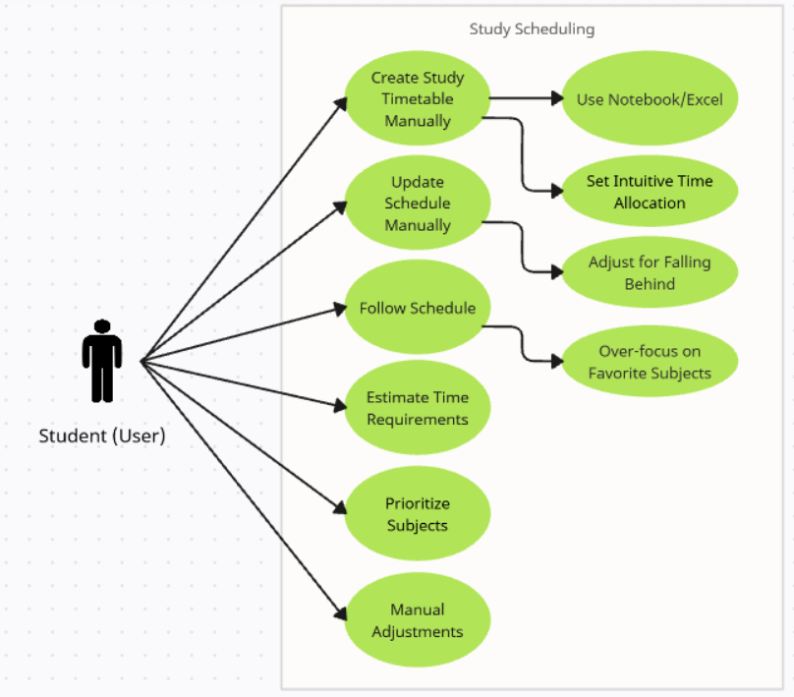

3.2.2. Use Case Diagram of Proposed System
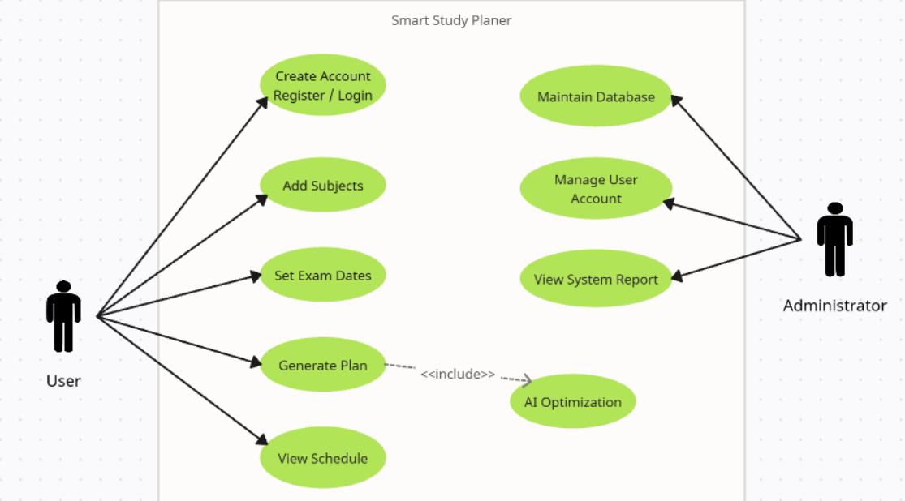

3.2.3. Class Diagram of Proposed System
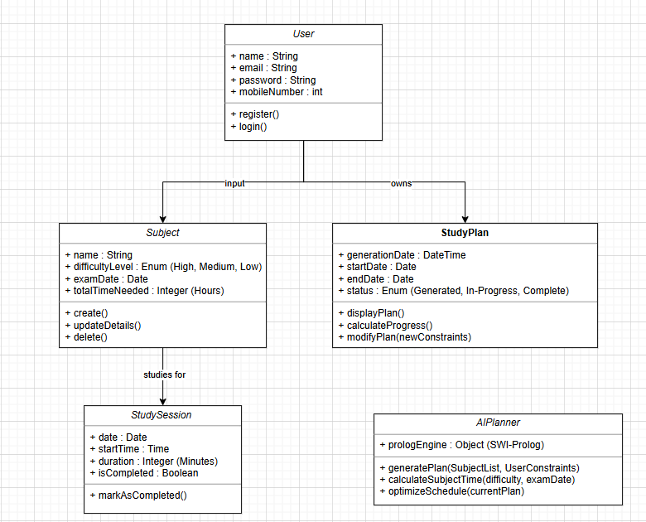

3.2.4. Sequence Diagram of Proposed System
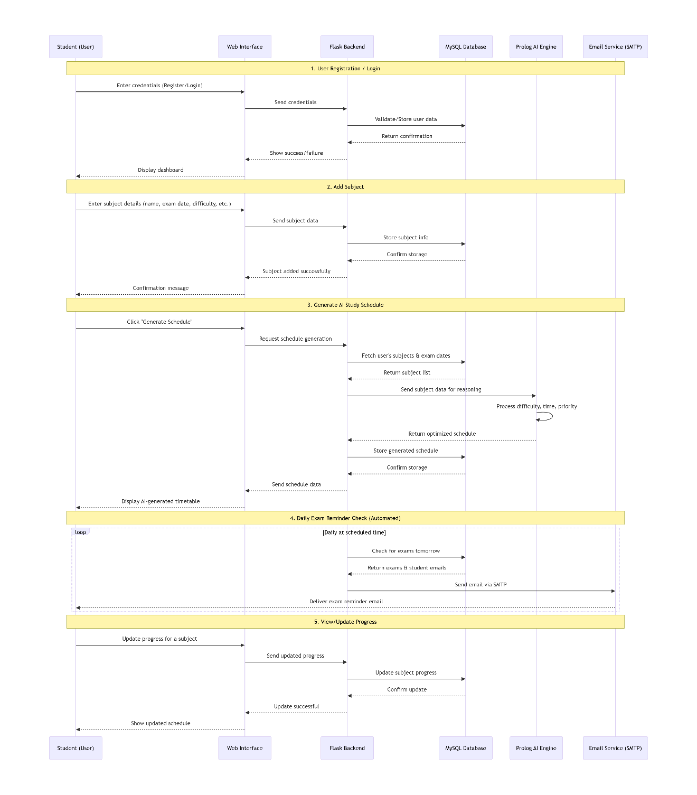

3.2.5. ER Diagram of Proposed System3
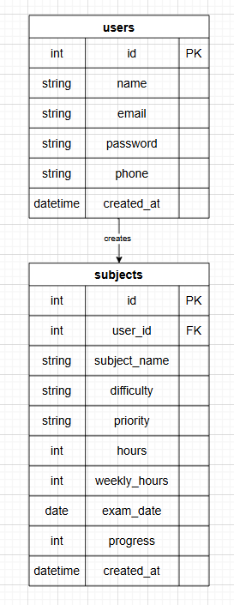

Chapter 4
Solution Design

4.1 Introduction
The solution design for the Smart Study Planner focuses on providing a complete, user-friendly, and AI-assisted web system. The design ensures that students can easily input subjects, exam dates, and difficulty levels, and the system will generate optimized study schedules using Prolog AI logic. The design includes clearly defined interfaces, database structures, and report layouts to support both functionality and usability.

4.2 Interface Design
Interface | Description
Home page | Provides navigation to the study planner, displays login/sign-up options, and shows an overview of the system.
Signup/login | Allows users to create an account or login to access personalized study schedules.
Add subject page | Users can add subjects with details like subject name, exam date, difficulty level, weekly hours, and current progress
Generate schedule | Students click this to generate AI-based study schedules after adding subjects.
Study schedule display | Shows the generated study timetable with allocated study hours per subject and exam reminders.
Email reminder system | Sends email notifications to students about exams scheduled for the next day.

4.3 Database Design
Table name | Primary key | Foreign key | Description
users | Id |  | Stores user information such as name, email, and login credentials.
subjects | id | user_id | Stores subjects added by each user including exam date, difficulty level, weekly hours, and progress.

4.4 Database Design

Report Layout No | Report Layout Name | Description
1 | Study Schedule Report | Displays the AI-generated study timetable for students. Shows subject names, allocated hours, and exam dates.
2 | Email Reminder Report | Logs all email reminders sent to students for upcoming exams.

Chapter 5
Conclusion
The Smart Study Planner project successfully developed an AI-powered web application that helps students plan and manage their study schedules. The system integrates HTML, CSS, JavaScript for frontend, Flask for backend, MySQL for data storage, and Prolog AI reasoning for generating optimized study schedules.
Achievements:
- Users can create accounts, add subjects, and generate personalized study timetables.
- The system provides automated exam reminders via email.
- AI logic ensures fair distribution of study hours according to difficulty, priority, and urgency.
- Fully functional web interface with responsive design.
Weaknesses / Limitations:
- Email reminders rely on Gmail SMTP; other email services may need separate configuration.
- No mobile application version yet.
- The AI rules are basic; future versions could include more advanced algorithms like adaptive learning based on performance history.
Future Enhancements:
- Integrate more complex AI for adaptive learning.
- Mobile app version for easier access.
- In-app notifications instead of only email reminders.
- Graphical analytics showing study performance trends.
References:
SWI-Prolog Documentation. (2025). Retrieved from https://www.swi-prolog.org/documentation
Appendices:
- Project Schedule – Timeline from proposal to final implementation.
- Meeting– Notes and lessons from meetings with our lecturer.
- Questionnaires / Interview Questions – Used for understanding student study habits.
- Software Setup Files – Flask app, Prolog logic, database scripts, and configuration files.
- Screenshots of UI , Database , python with flask and Email reminder.

UI: 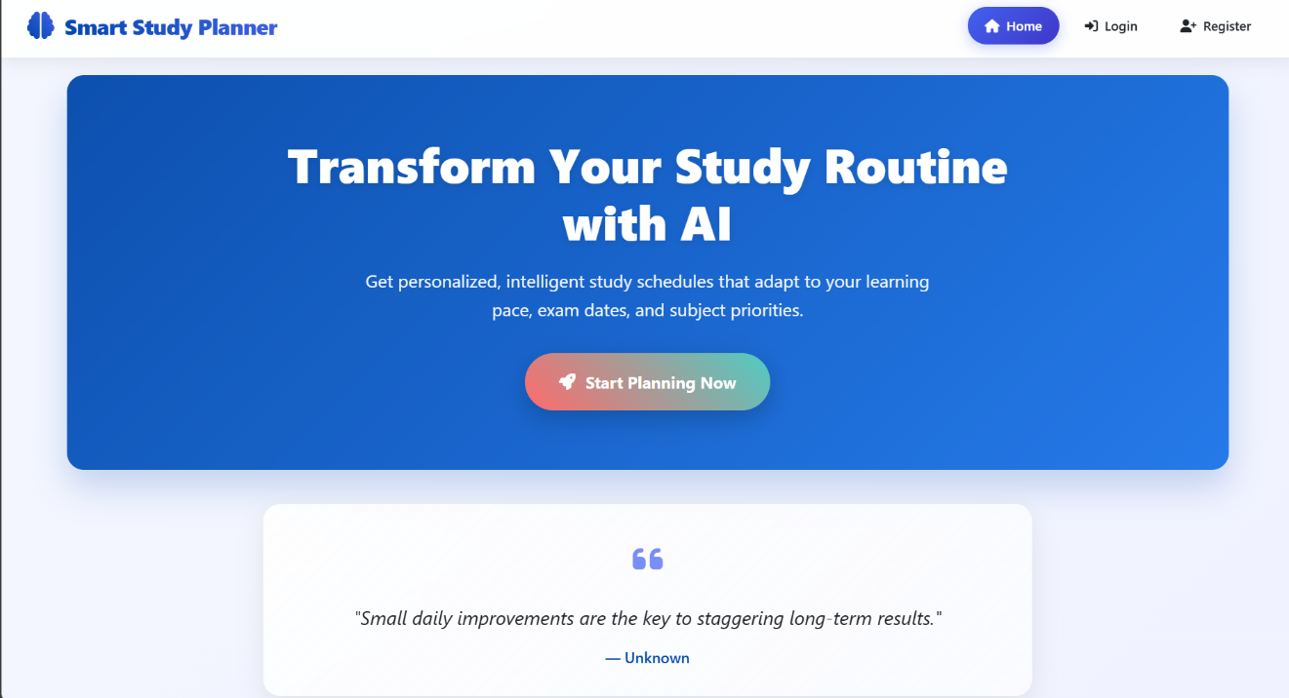
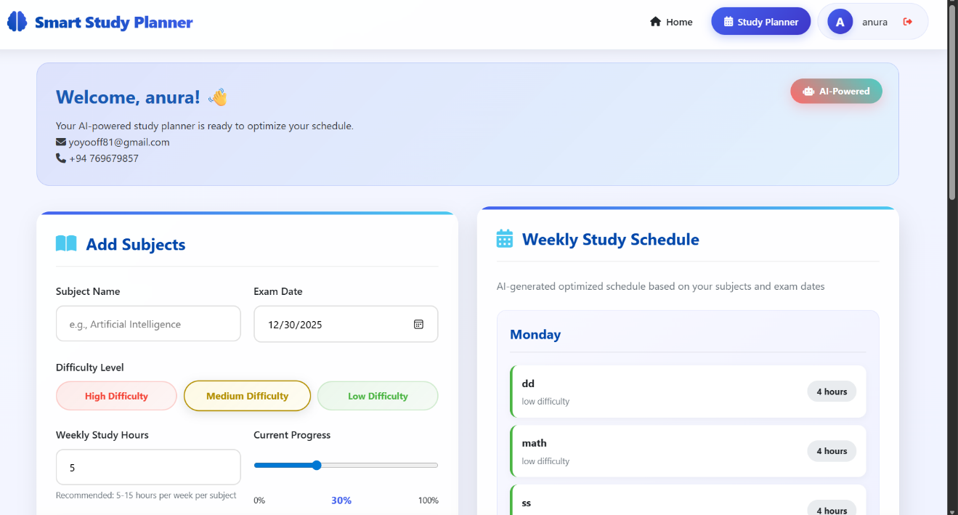.
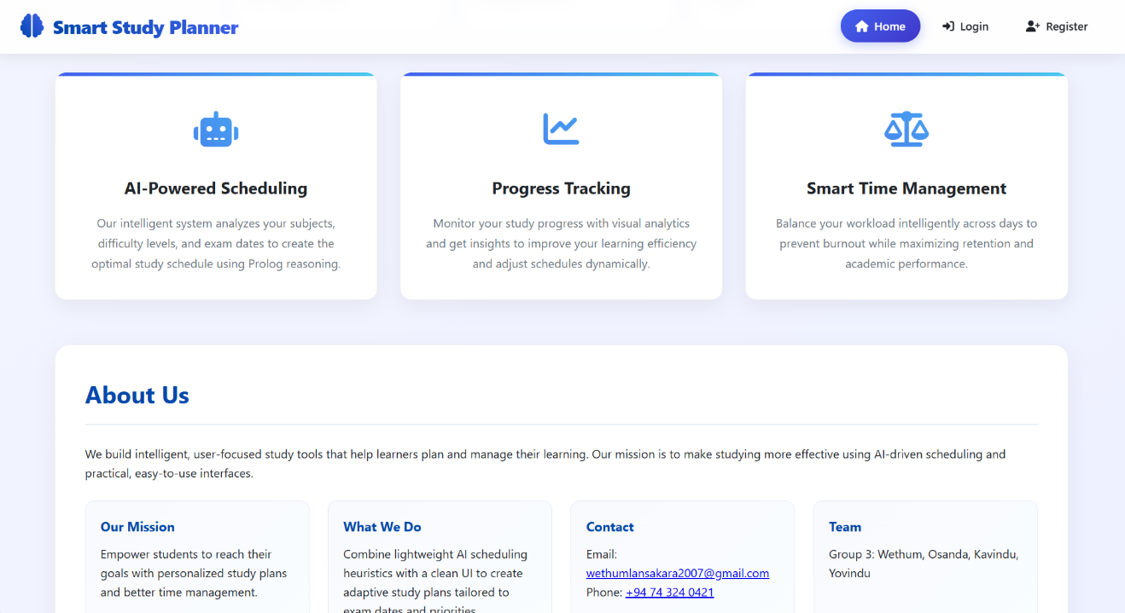
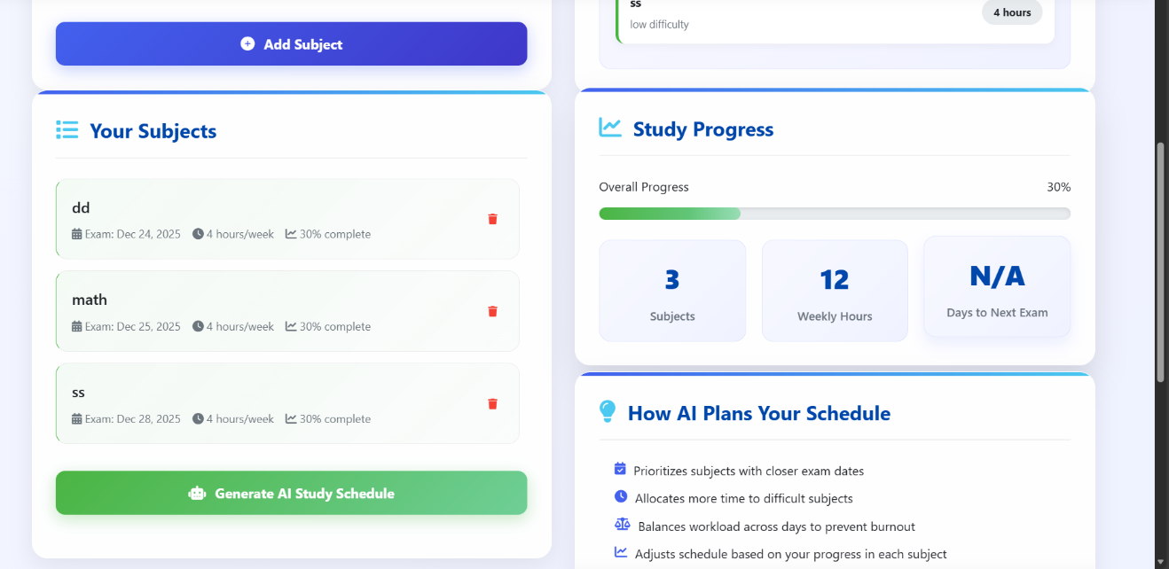

Database:

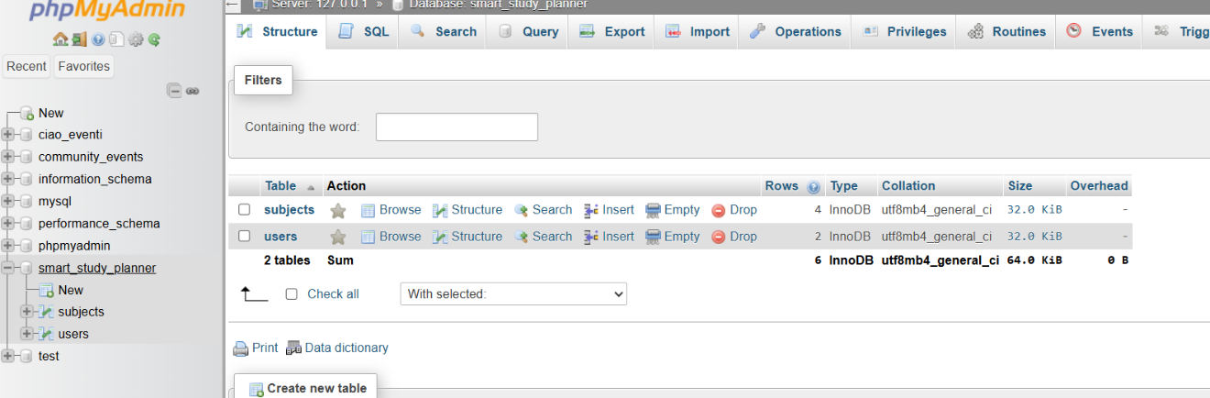

Prolog and Python:

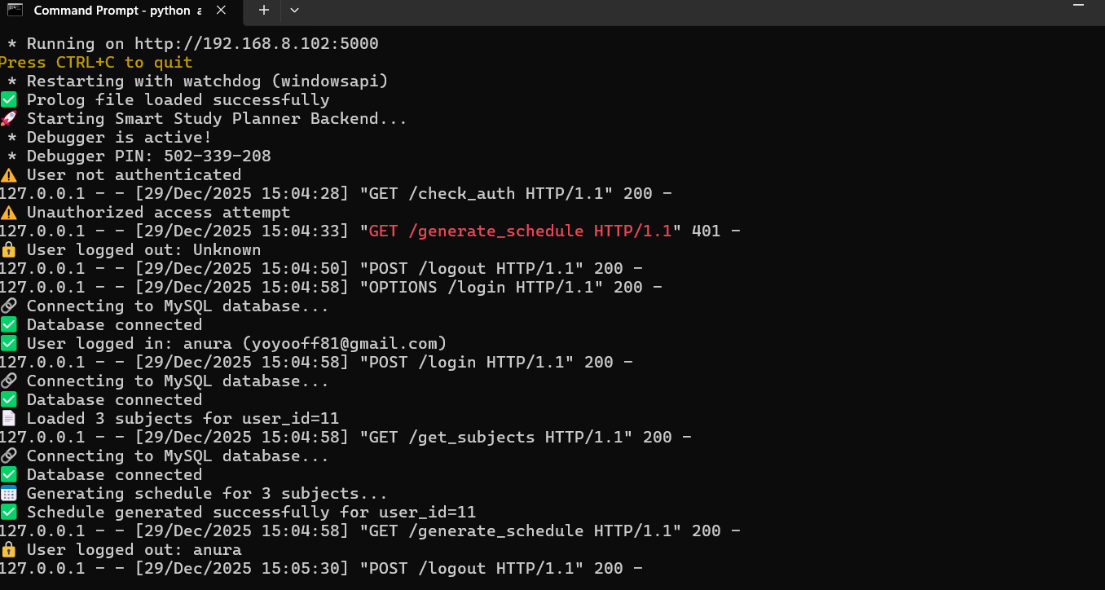

Email Reminder:

